**Assigning Relationship Manager Solicitors in RE**

Contents

**Adding a new Relationship Manager (if there is no current RM on the record):** 1

**Changing the Relationship Manager to a different person:** 1

**Removing the LG Relationship Manager/ adding the donor to a Midlevel portfolio:** 1

*Remember:*

* *Complete the same solicitor changes to the constituent’s Non-Master Record(s) and Non-Head of Household records.*
* *There can only be one Relationship Manager on each constituent record.*

# **Adding a new Relationship Manager (if there is no current RM on the record):**

1. Select the “**Relationships**” tab in the constituent record. Select the “**Assigned Solicitors**” option in the left-hand list.

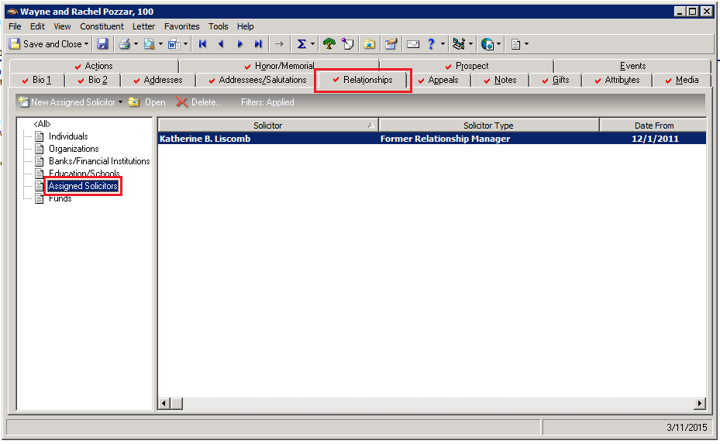

1. Select “**New Assigned Solicitor**”.
   1. Search for the **solicitor’s name** in the “Solicitor” field (e.g. David Whalen)
   2. Select “**Relationship** **Manager**” from the drop-down under the “Solicitor type” field.
   3. Enter **today’s date** in the “Date from” field.

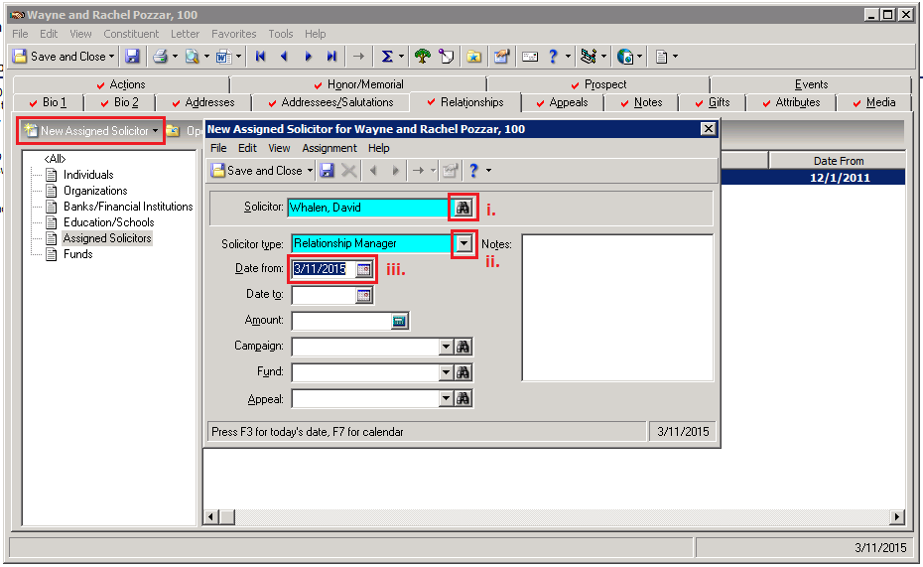

* 1. Save and Close the window.

# **Changing the Relationship Manager to a different person:**

1. Select the “**Relationships**” tab in the constituent record. Select the “**Assigned Solicitors**” option in the left-hand list.
2. Open the window for the CURRENT/OLD Relationship Manager (e.g. Joey Pierce).
   1. Change the “Solicitor type” field to “**Former Relationship Manager**”.
   2. Enter **today’s date** in the “Date to” field.

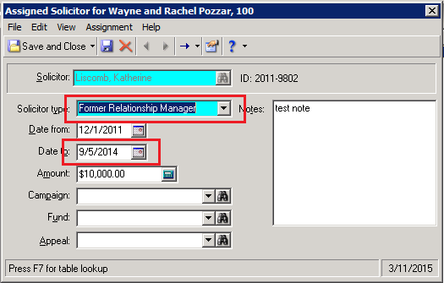

* 1. Save and Close the window.

1. Add new Assigned Solicitor: See Part One

*Note: If the solicitor was a Relationship Manager on the record previously, was removed, and now is being re-assigned as a Relationship Record, you must add them as a NEW assigned solicitor with today’s date. The same solicitor may be listed multiple times as a solicitor on a record, but as a Former Relationship Manager.*

# **Removing the LG Relationship Manager/ adding the donor to a Midlevel portfolio:**

1. Select the “**Relationships**” tab in the constituent record. Select the “**Assigned Solicitors**” option in the left-hand list.
2. Open the window for the CURRENT/OLD Relationship Manager (e.g. Joey Pierce).

See Part Two for instructions marking current RM as Former Relationship Manager

1. Select “**New Assigned Solicitor**”.
   1. Search for the **NEW solicitor’s name** in the “Solicitor” field (e.g. Andrew Firger), and select “**Relationship** **Manager**” from the drop-down under the “Solicitor type” field.
   2. Enter **today’s date** in the “Date from” field.
   3. Enter “**Non Gift Solicitor**” in the “Fund” field.

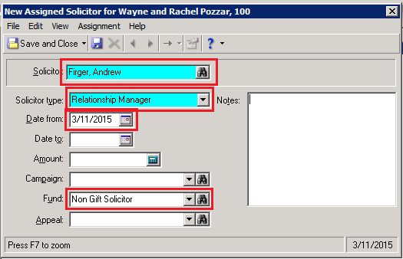

* 1. Save and Close the window.